|  |
| --- |
|  |
| The Specification |
| TMWdaily |
|  |
| **roro** |
| **1/8/2012** |

[Type the abstract of the document here. The abstract is typically a short summary of the contents of the document. Type the abstract of the document here. The abstract is typically a short summary of the contents of the document.]

A simple Webapp

Home

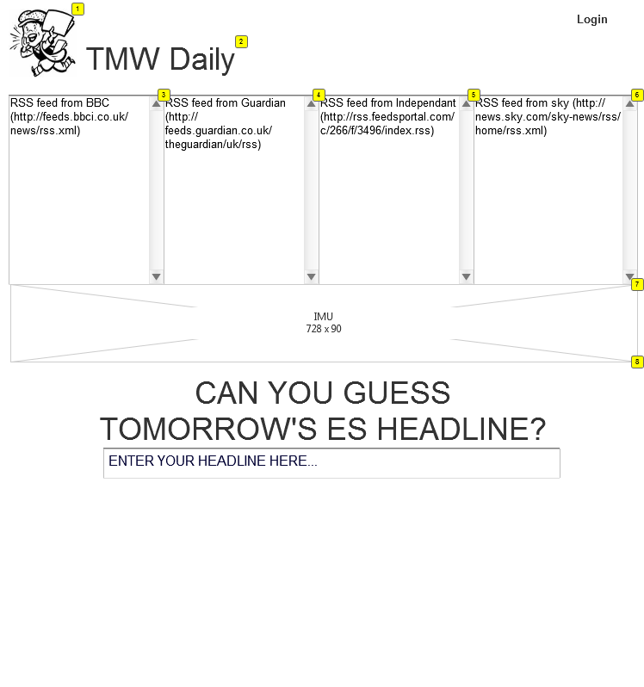

* + 1. Widget Table

|  |  |  |
| --- | --- | --- |
| Footnote | Label | Description |
| 1 | Logo | A paper boy (to be edited and colored) |
| 2 | Name | TBC |
| 3 | Feed box | (http://feeds.bbci.co.uk/news/rss.xml) |
| 4 | feed box 2 | http://feeds.guardian.co.uk/theguardian/uk/rss) |
| 5 | feed box 3 | (http://rss.feedsportal.com/c/266/f/3496/index.rss) |
| 6 | feed box 4 | http://news.sky.com/sky-news/rss/home/rss.xml) |
| 7 | Ad banner | banner 780x90 (dont worry for the advertisers hehe) |
| 8 | Main section | where User will submit his headlines and interact |

* + 1. Main section
       1. Submit your Headline

A simple question (a real call to action), followed by a text box. Nothing to distract User’s attention.

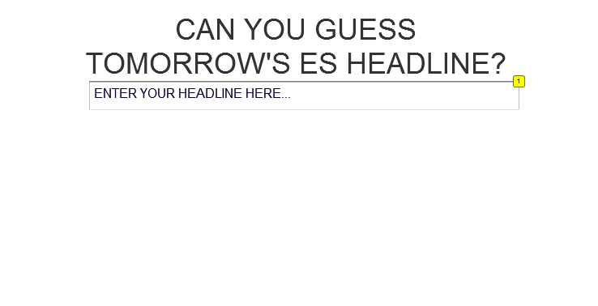

* + - 1. Widget Table

|  |  |  |  |  |
| --- | --- | --- | --- | --- |
| Footnote | Label | Interactions | Description | Effort |
| 1 | Headline | OnFocus:  Case 1  (If text on widget Headline equals "ENTER YOUR HEADLINE HERE..."):  **Set text on widget Headline equal to ""**  **Show “Options” fade 500ms**  OnLostFocus:  Case 1  (If text on widget Headline equals ""):  Set text on widget Headline equal to "ENTER YOUR HEADLINE HERE..." | User can type in his guess for tomorrow's Evening Standard headline | Submissions are limited in time. As soon as the headlines have been chosen and printed, The text fields strarts accepting submissions for the next day. |

* + 1. “Options” (appears when the text box is on focus)

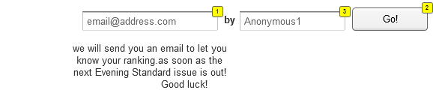

* + - 1. Widget Table

|  |  |  |  |  |
| --- | --- | --- | --- | --- |
| Footnote | Label | Interactions | Description | Effort |
| 1 | email address | OnFocus:  Case 1  (If text on widget email address equals "email@address.com"):  Set text on widget email address equal to ""  OnLostFocus:  Case 1  (If text on widget email address equals ""):  Set text on widget email address equal to "email@address.com" | User types in his email address | has to be in correct format |
| 2 | Go button | OnClick:  Case 1:  Set Main section state to Share fade in 500ms | Validates the headline | links to the next frame (fade) |
| 3 | username | OnFocus:  Case 1  (If text on widget username equals "Anonymous1"):  Set text on widget username equal to ""  **Show Sign up and Go fade 500ms**  OnLostFocus:  Case 1  (If text on widget username equals ""):  Set text on widget username equal to "Anonymous1" | User can type in his username. If he types a new username (different than the automatically generated, **he triggers the sign-up process** | by default, a username is generated, (according to the IP address?) Username has to be cecked if does not already exist on the database |

* + 1. Sign up and Go

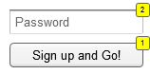

* + - 1. Widget Table

|  |  |  |  |  |
| --- | --- | --- | --- | --- |
| Footnote | Label | Interactions | Description | Effort |
| 1 | Go button | OnClick:  Case 1:  Set Main section state to Share fade in 500ms | Validates the headline | links to the next frame (fade) |
| 2 | password | OnFocus:  Case 1  (If text on widget password equals "Username"):  Set text on widget password equal to ""  OnLostFocus:  Case 1  (If text on widget password equals ""):  Set text on widget password equal to "Username" | User can type in his password | verification of strength |

* + - 1. Share

Logically, after having submitted your guessed Headline, you can share it (and the picture of it) through Twitter and Facebook.

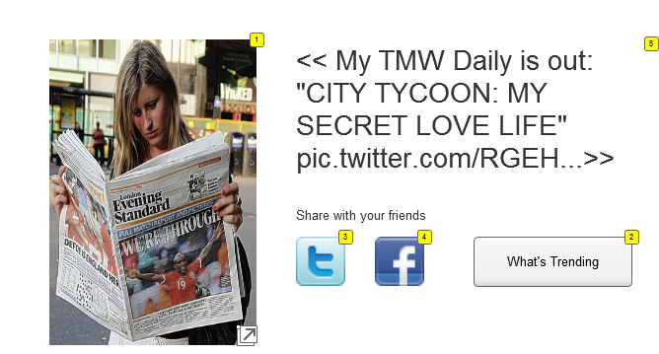

* + - 1. Widget Table

|  |  |  |  |  |
| --- | --- | --- | --- | --- |
| Footnote | Label | Interactions | Description | Effort |
| 1 | Simulation |  | Picture of a fake Evening Standard Issue featuring the title chosen by User. A placeholder on the image (if too difficult, will happen in v.2, but I think it is funky enough to trigger the sharing) | User can download pic (insert in title via TMWdaily.com) |
| 2 | Trends button | OnClick:  Case 1:  Set Main section state to Leaderboard fade in 500ms | User can see the trends (what people have been guessing) | triggers the last state |
| 3 | twitter button |  | triggers the twitter connect pop out |  |
| 4 | facebook button |  | triggers the facebook connect pop out |  |
| 5 | Twit Example |  | Automatically generated message (140 character max) that includes the sentence "My TMWdaily is out! followed by the Headline written by User, followed by the twit pic link of the photo. Cut if too long, but keep the link enbedded in the message. |  |

* + - 1. Leaderboard
      2. User Interface

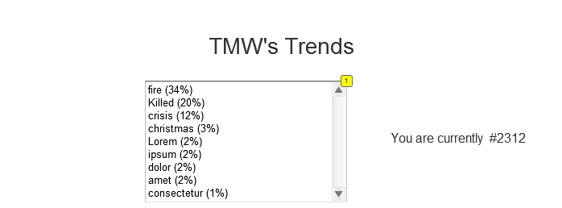

* + - 1. Widget Table

|  |  |  |
| --- | --- | --- |
| Footnote | Label | Description |
| 1 | Trends rating | a calculator will rank the use of words guessed by Users. If a total of 10 words were submitted by 2 users and "crime" was cited twice. it would be: "crime" (20%) |
| 2 | ranking | an algorithm will establish if you are your ranking according to the accuracy of your guess v. the actual headline |